**Retiring Employees and Mentorship Program Opportunity**

Research into Pewlett-Hackard was performed to identify the quantity of retirement aged employees by name, title, dob, and dates of employment. This research was performed in order to prepare Pewlett-Hackard for future facing impacts of high volume of retiring employees to the next generation for knowledge transfer and anticipation of new hires needed to continue to sustain the company and provide planning solutions for the upcoming ‘silver tsunami’.

In order to capture this information, PostgresSQL was performed on employee, department employee, and title tables and JOINED to create tables retirement_titles, unique_titles, and mentorship_eligibility. These tables were joined with primary key ‘emp_no’ to JOIN and quickly analyze the data along with birthdates and employment dates. An ERD was created to showcase the relationship of the schema (Figure 1)

**Figure 1: ERD table capturing primary and foreign keys across various tables**

From the research, there are 90,398 employees that will retire, with 62,170 in Senior or Leadership roles (68.77%) Figure 2. With this impact of losing high quantity of senior level roles, there are opportunities for those in junior and mid roles to grow within the organization through a mentorship program. Through vertical growth, there will also be a need to staff the junior and mid roles to ensure that the velocity, quantity, and quality of work is maintained for the organization’s sustainability. In order to validate the possibility of a mentorship role and transition, we performed further analysis of our data through employee birthdates from 1/1/1965 – 12/31/1965 and identified 1940 employees that can take part in this program.

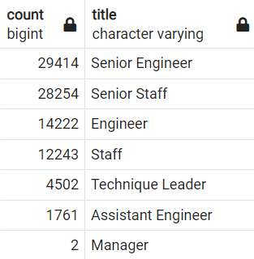

**Figure 2: Retiring Employees by Title**

In conclusion, there are 90,398 employees that will need to have their roles filled within the retirement window and 1940 employees that are eligible to choose for the transitional program. With insights from data, we need to prepare SOP (standard operating procedures) to ensure the success and acceptance criteria of this initiative to ensure that a wide gap is not in place within a few months. This will require staffing across the engineering teams as well as staffing up HR to better be able to position themselves for success.